**Lab3: Diabetic Retinopathy Detection**

Author: 311553007應耀德

1. **Introduction**

**Lab Objective:**

In this lab, you will need to analysis diabetic retinopathy (糖尿病所引發視網膜病變) in the following three steps. First, you need to write your own custom DataLoader through PyTorch framework. Second, you need to classify diabetic retinopathy grading via the ResNet architecture. Finally, you have to calculate the confusion matrix to evaluate the performance.

**Requirements:**

1. Implement the ResNet18, ResNet50 architecture and load parameters from a pretrained model.
2. Compare and visualize the accuracy trend between the pretrained model and without pretraining in same architectures, you need to plot each epoch accuracy (not loss) during training phase and testing phase.
3. Implement your own custom DataLoader.
4. Calculate the confusion matrix and plotting.

**Data - Diabetic Retinopathy Detection (Kaggle):**

Diabetic retinopathy is the leading cause of blindness in the working-age population of the developed world. It is estimated to affect over 93 million people. This dataset provided with a large set of high-resolution retina images taken under a variety of imaging conditions.

Image format: .jpeg

Image size: 512 x 512

Number of images: 25,124 images

*Reference:* [*https://www.kaggle.com/c/diabetic-retinopathy-detection#description*](https://www.kaggle.com/c/diabetic-retinopathy-detection#description)

* Train data: train_img.csv, train_label.csv, 28,009 total images

Test data: test_img.csv, test_label.csv, 7,025 total images

Figure 1. Label distribution for data

**Loss functions:**

* Cross-Entropy Loss

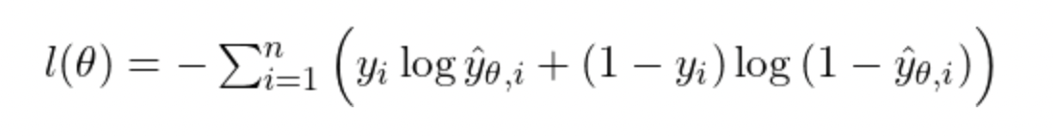

Where

$n: number of data points$

$i: index of data points$

$θ: weights$

$\hat{y}: predict result$

$y: ground truth$

**Optimizer:**

* Adam (Adaptive Moment Estimation)

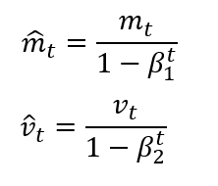

Where

1. **Experiment setups**

**Shared settings:**

* Batch Size: 512
* Epoch Size: 500
* Optimizer: Adam, learning rate = 0.001, weight decay = 0.1
* Loss function: Cross-Entropy Loss

**The details of your model (ResNet):**

**Dataset and Dataloader:**

**Confusion matrix:**

1. **Experimental results**

**Result:**

|  |  |  |
| --- | --- | --- |
| **Network** | **pretrained** | **from scratch** |
| ResNet18 | 73.76% | 74.15% |
| ResNet50 | **84.14%** | 83.35% |

**Confusion matrix:**

**Comparison figures:**

Note: To use the same hyperparameters, I choose an appropriate set of hyperparameters to fit the data.

1. **Discussion**